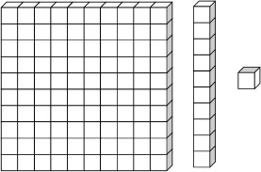
Name: _____________________________________________
Place Value Art Gallery Worksheet
Guess how much my picture is worth!
Student Name | Picture Value | Show my work | Actual Value

Student Name | Picture Value | Show my work | Actual Value

Student Name | Picture Value | Show my work | Actual Value

Whose picture has the greatest value? ___________________________________________
How do you know? ________________________________________________________________________________________________________________________________________________________________________________________________________________________________________________________________________________________________________________________________________________________________________________________________ .

